**1.** **Introduction**

Microfluidics studies fluid behavior through channels on micro-scaled chips. Microchips possess advantages compared to traditionally sized apparatus: they are cheap to manufacture [1] and are better suited for studies in fields at the micro-scale e.g nanotech and pharmacology [2].

This lab teaches students the practical skills needed to operate this technology. Students will observe velocity profiles according to various flow paths within the micro-chip through a microscope. This lab considers 2 equations. The conservation of mass states that the amount of incompressible fluid per unit time passing through two points in space is constant:

$ρU_{A}S_{A}= ρU_{B}S_{B}$ (1)

Rho is the density, U the velocity and S, the area. A and B are arbitrary points along the same streamline. The Bernoulli equation is an energy balance applied to fluids: the sum of pressure, kinetic and potential energies remain constant

$P_{A }+ \frac{1}{2}ρ{U_{A}}^{2} + ρg z_{A} = P_{B}+\frac{1}{2}ρ{U_{B}}^{2} + ρgz_{B}$ (2)

**2.** **Experimental Procedures**

Follow the procedure from the lab manual [1]. Make sure to not touch the petri-dish or the tubing attached to it, as any tiny bump will throw off the image on the microscope. Each image has a length scale. Using an editor like preview, or MS-paint, calculate the conversion of pixels to micrometers: measure the pixel length of the scale and divide the micrometer scale length. Thus, the distance of any streak can be calculated by first finding its length in pixels and then multiplying it by the conversion factor

**3. Results and Discussions Lab Questions:**

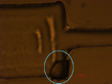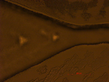

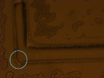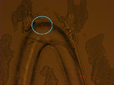

*Figure 1: Different channel geometries within the chip: (a) abrupt opening, (b) gradual opening, (c) sharp bend, (d) sine bend. Imperfections are relatively small compared to the scale of the channels except for in 1a, where there is a large divot at the bottom.*

**Chip Design:**

The abrupt opening (figure 1a) has a large divot in the bottom corner. The “sharp” bend (figure 1c) has some smoothness as opposed to a right angle. Similarly, the sine bend (figure a) is not perfectly curved along the top wall. In figure 1a, the size of the square divot is around 250 µm x 240 µm, which is significant, as the opening is. around 200 µm. The blunt bend in figure 1c could have caused more efficient momentum transfer. The bump imperfections are on the scale of 20~30 µm, which in theory cause momentum dissipation and turbulence; in practice, their effects can be ignored as they approximate smooth surfaces at 5x and 10x zoom.

**Straight Channels:**

Max velocity for a straight channel is expected to be at the center. The closer a streamline is to the channel wall, the greater the effect of shear becomes—shear dissipates momentum, and decreases the speed of the flow. Thus, at the center of the channel, flow is the furthest away from the effects of the walls. Due to the no slip condition, velocity at walls is 0, the profile is parabolic in nature, thus at the walls, the velocity is gradient.

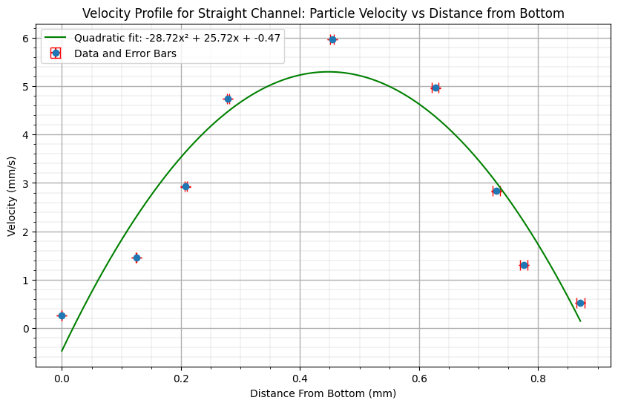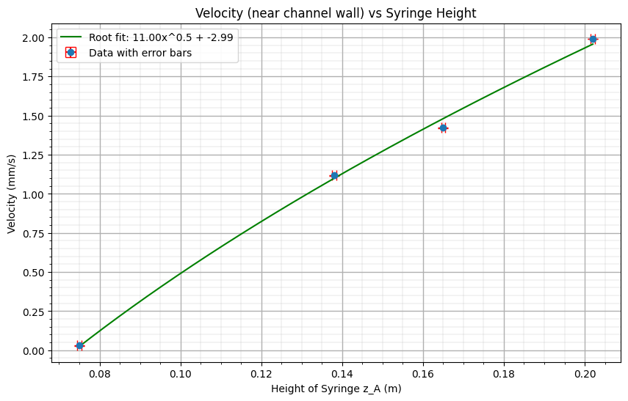

*Figure 2: (a) Parabolic velocity profile for straight channel yields R2 = 0.8912. (b) Velocity as a function of the height. Root fit yields R2 = 0.9975.*

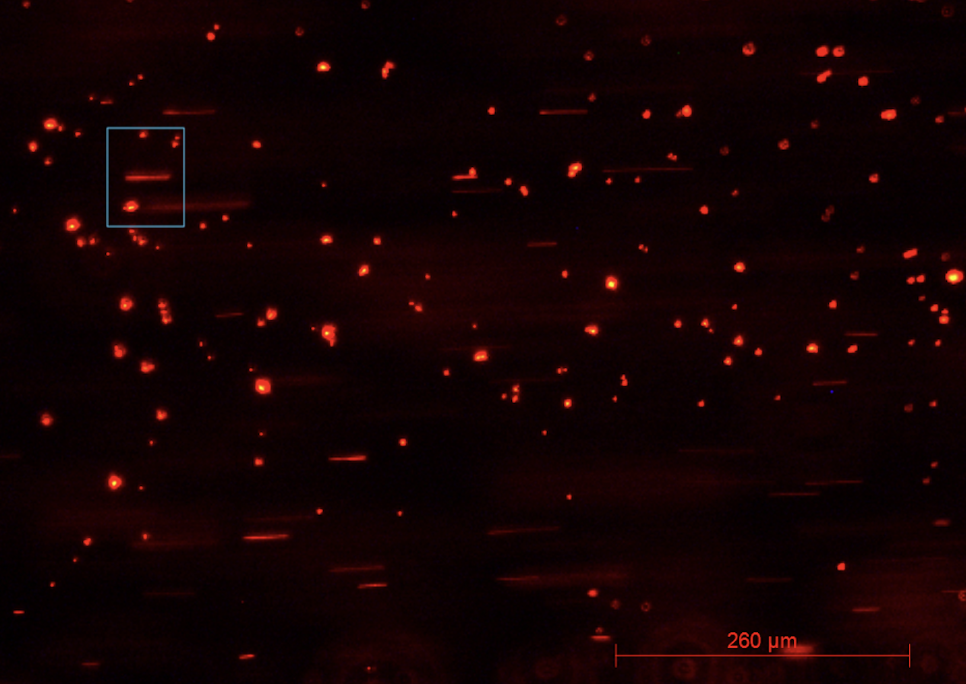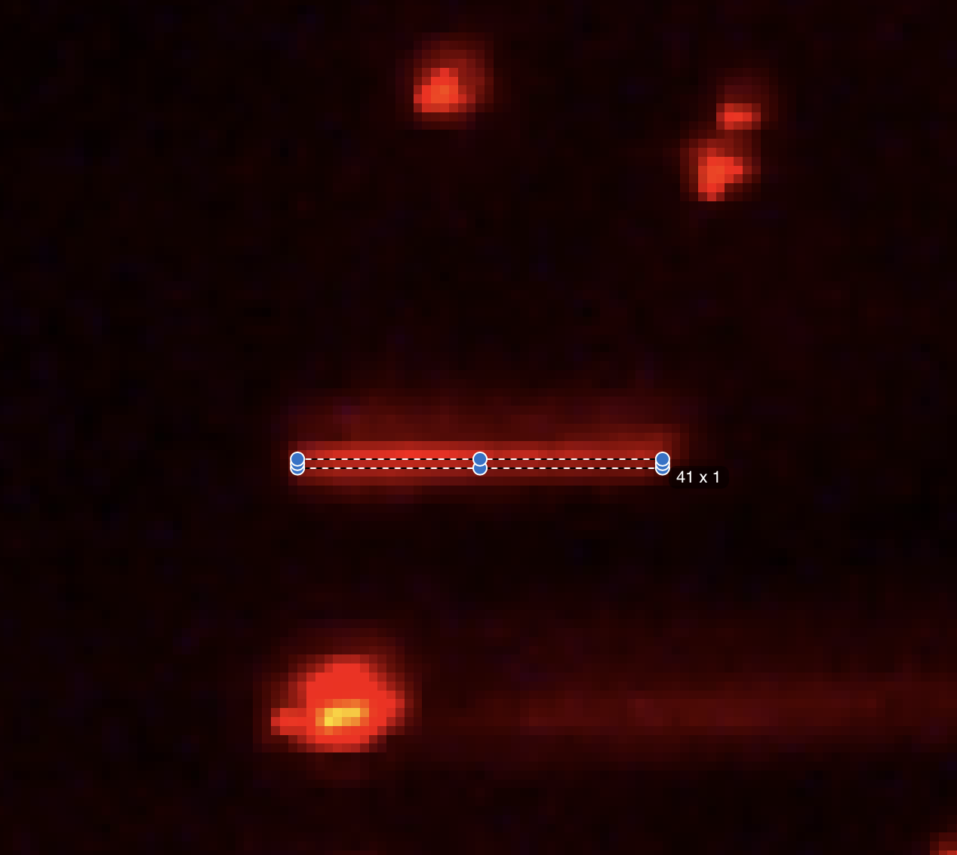

*Figure 3: (a) Straight channel flow. (b) Using preview on mac to measure the length of a streakline in pixels.*

A parabola is the expected velocity profile of a closed straight pipe. Although only 9 streak lines were measured to generate figure 2a, they agree with the parabolic regression.

Velocity in the straight channel varies in accordance with the Bernoulli equation (2). Let point A represent the liquid in the syringe, held above the chip. Let point B be the location of the straight channel in figure 3a. Let us make 2 assumptions: the fluid velocity moving downwards in the syringe is negligible, so UA = 0 and the pressure PA is equal to the sum of the ambient pressure and the weight of the fluid over the syringe area. (2) becomes: $P_{atm }+\frac{mg}{A_{syringe}}+ρgΔz = P_{B}+\frac{1}{2}ρ{U_{B}}^{2}$ .

Thus, UB increases if we increase the ambient pressure, the amount of liquid, the density of the liquid and the height of the syringe. UB also increases by decreasing the area of the syringe.

By changing the height of the syringe, we measure the velocity of particles; when modeled with a root fit in figure 2b, R2 = 0.9975.

The root relationship can be further derived from the equation above. Let us assume that the pressures at point A and B are the same:

$ρg z_{A} = \frac{1}{2}ρ{U_{B}}^{2} +ρg z_{A} →U_{B}=\sqrt{2ρg(z_{A}-z_{B})} →U_{B}=\sqrt{2ρh(Δz)}$

This equation is known as Torricelli's law which states that the fluid velocity at some point is proportional to the square root of the difference in height.Note that figure 3b yields the same relation but translated horizontally to the right. At a non-zero height differential (zA = 0.075 m), the flow velocity was zero. This is likely due to the energy lost due to the friction between the long, narrow plastic tubing and the liquid before it enters the chip.

**Channels of Different Size:**

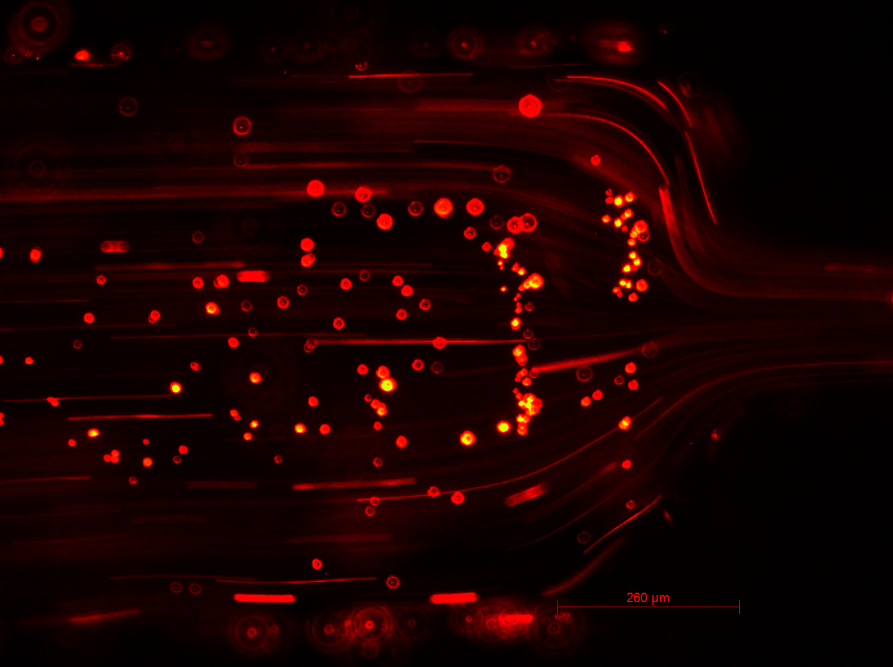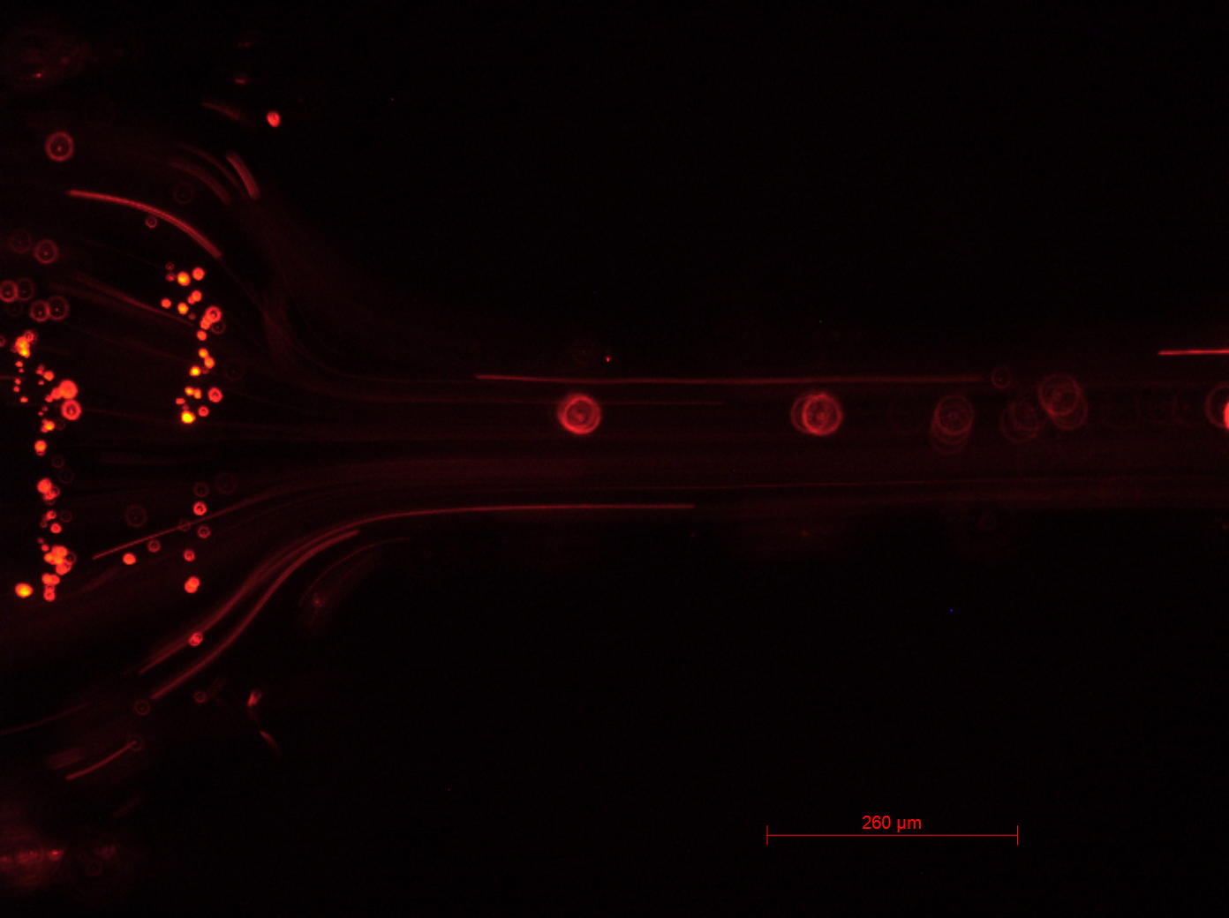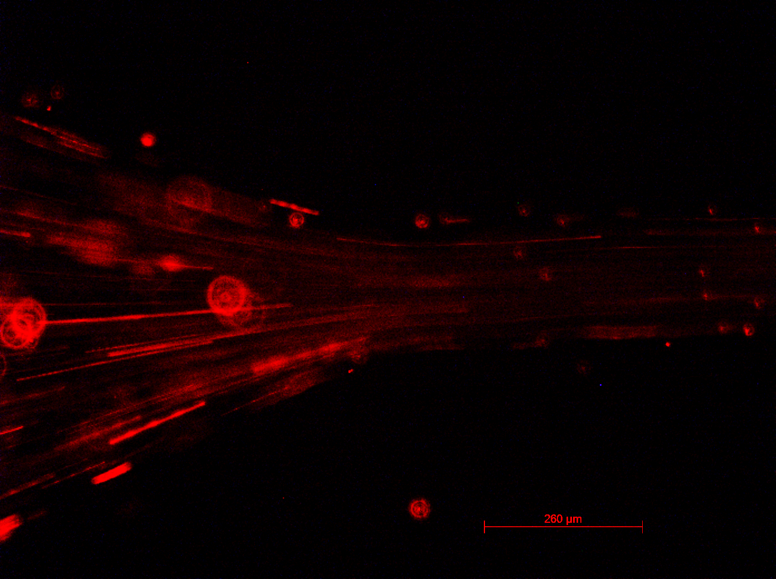

*Figure 4: (a) wide channel for abrupt opening. (b) narrow channel for abrupt opening. (c) gradual opening.*

The theoretical velocity can be found using the mass continuity equation (1): $ρU_{A}S_{A}= ρU_{B}S_{B}$, which allows us to calculate the theoretical exit velocity through the following assumptions:

By measuring the lengths of the narrow and wide channels, we can calculate the ratio of their cross-sections by taking the ratio of their lengths assuming the depth (into the page) remains constant. The fluid is incompressible and thus density is constant. The velocity profile is uniform. Note that this isn’t true as we had established that the velocity profile is parabolic in nature. This is why measurements of before and after are taken near the border of the channel. The above assumptions allow us to simplify (1) to $U_{B} = \frac{l_{A}}{l_{B}}U_{A}$

**Abrupt**: Uinitial = 4.199 ± 0.002 mm/s, Ufinal = 1.295 ± 0.002 mm/s. The theoretical final velocity is 1.192 mm/s ± 0.005 mm/s. The percentage error is 8.67%.

**Gradual:** Uinitial = 3.917 ± 0.003 mm/s and Ufinal = 1.235 ± 0.002 mm/s. The theoretical final velocity is 1.188 ± 0.005 mm/s. The percentage error is 4.57%.

As the cross sectional area of the profile increases, the velocity decreases, we can see that area and velocity have an inverse relationship from the above calculations. This verifies equation (1).

The discrepancy between theoretical and measured values have to do with the assumptions made above. The continuity equation assumes that the two measurements in space A and B are along the same streamline; however, it is not possible to track a unique particle as it travels through the opening. Instead, the velocity of two distinct particles that were roughly the same distance away from the channel were measured in order to obtain UA = Uinitial and UB = UFinal. The gradual opening leads to no turbulence, and no curl. Streaklines transitioning from the narrow to the wider areas are straight. The abrupt transition caused streaklines to curl and become distorted; still, minimal turbulence was observed. Streaklines coming from the center of the velocity profile remained straight while particles near the channel boundary curved/bended outwards. Flows and flow transitions are pervasive in daily life due to the ubiquity of fluid transportation: water, oil, gas, refrigerants etc. Smooth transitions in fluid dynamics are preferred for their efficiency, reduced energy loss, and enhanced control, contributing to the longevity of materials. These considerations in engineering systems aim to optimize processes and technologies for improved performance and cost effectiveness.

**Channels with Bends:**

It is expected velocity drops more for the sharp bend than for the sine bend. The sharp bend is at 90° (figure 5a). The momentum of fluid particles before the bend is concentrated in the x-direction, so when it hits the wall, it loses most of its momentum, and gets pushed along the upper channel at a significantly lower speed. Losses in the sine bend are expected to be proportionally smaller than those in the sharp bend because the change of direction is gradual.

At the corner of the sharp bend there is flow separation and turbulence. Before and after the sharp bend the flow is laminar as shown in figure 5a. For the sine bend, the drop in velocity is far less pronounced. We observe laminar flow throughout the sine bend (figure 5b).

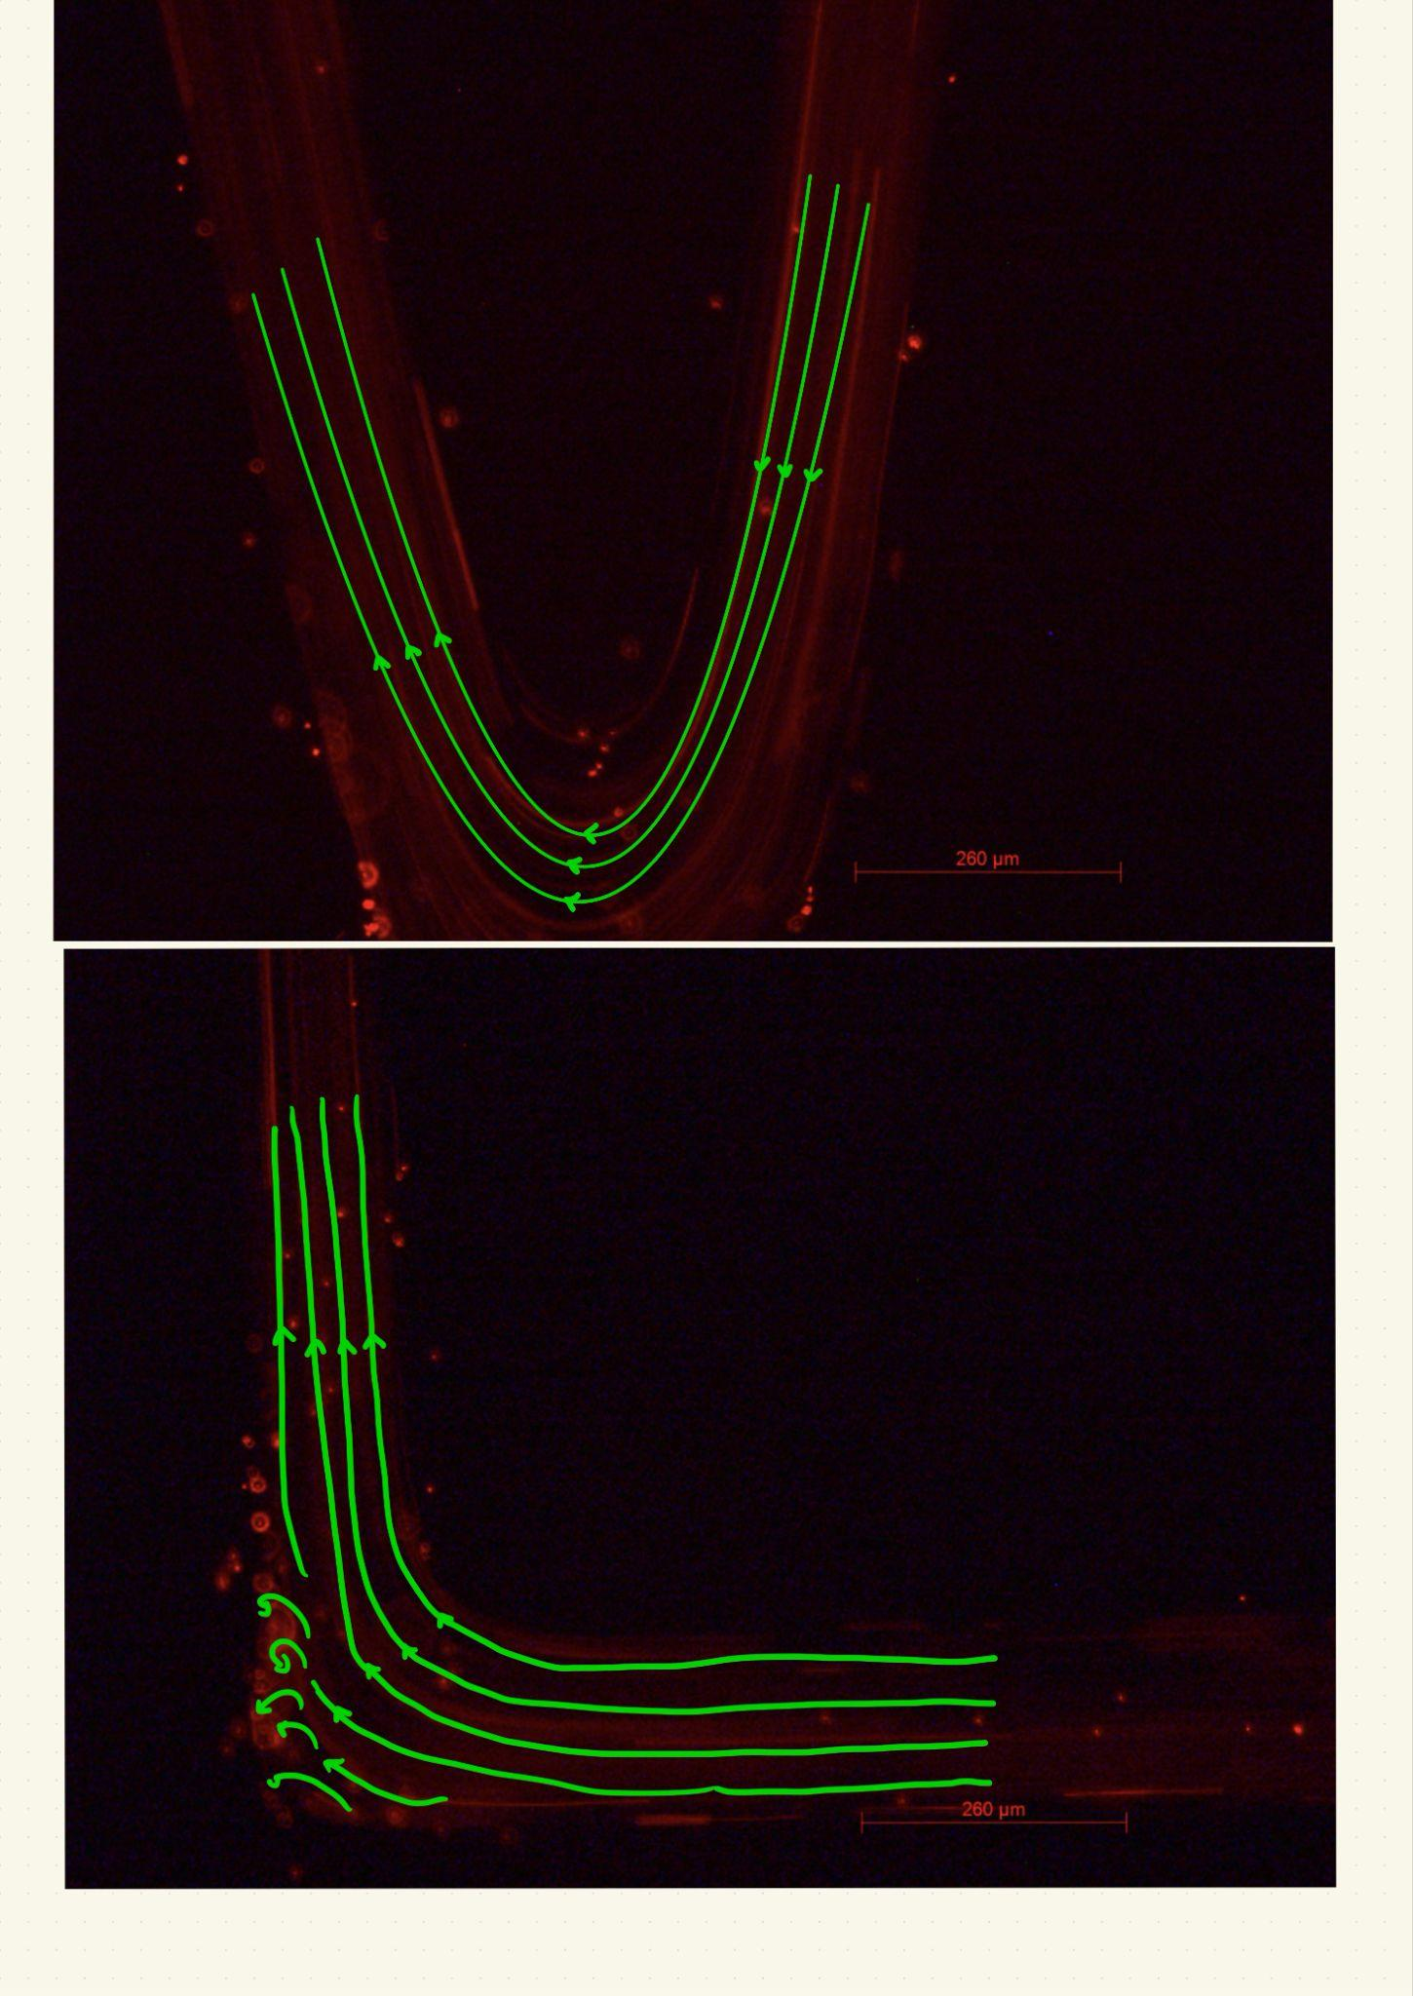

*Figure 5: (a) sharp bend with path lines, flow separation and turbulence. (b) sine bend with path lines, laminar flow.*

The entrance velocities were 4.107 ± 0.002 mm/s and 3.845 ± 0.002 mm/s and the exit velocities were 3.225 ± 0.004 mm/s and 3.497 ± 0.003 mm/s for the sharp bend and sine bend respectively. The sharp bend had a 21.47% reduction in speed whereas the sine bend had 9.08 % reduction in speed. As expected, the percent reduction in momentum (speed) was larger with the sharper bend than the sine bend.

**3.** **Error Analysis**

Uncertainties in length come from the pixel measurement in reading the start and end of the streak this human error is estimated as ± 2 px[1]. The scale has an uncertainty of ± 1 µm. In order to process these uncertainties, the following formula will be used, where xn is the n-th independent variable.

$Δf = \sqrt{({\frac{∂f}{∂x_{1}})}^{2} + ({\frac{∂f}{∂x_{2}})}^{2} + ... + ({\frac{∂f}{∂x_{n}})}^{2}}$ (3)

Thus, the conversion factor along with its computed tolerances is done using equation (3)

$$Conversion = \frac{Distance in μm}{Distance in px}=\frac{260 μm ± 1}{285 px ± 2 }=0.912 μm/px± 7 ×10^{-3}μm/px$$

**Sample Calculation for velocity:**

* Exposure time t = 58.5 ms ± 0.1.
* Displacement s = 41 px ± 2.
* Conversion = 0.912 µm/px ± 0.007 µm/px.

$$v =c s/t→(41 px±2)(0.912 ×10^{-3} mm/px ±7×10^{-6}) / (58.5 ms±0.1) =0.639 mm/s ±0.032 mm/s$$

The uncertainty is propagated through formula (3) as follows:

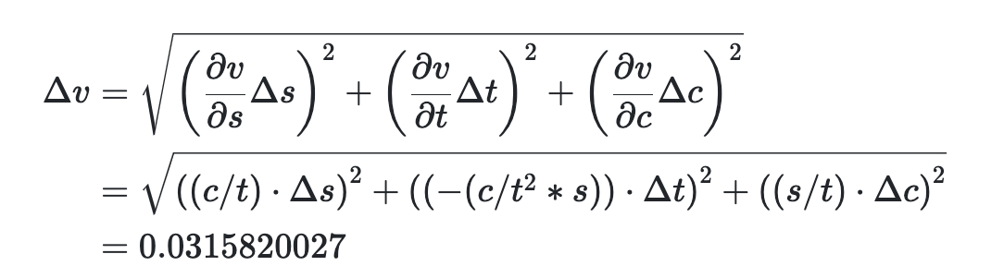

**Sources of Error: Assumptions of Bernoulli and Mass Continuity equation**

In the lab, we adopted the Eulerian approach in fluid mechanics by measuring particles across a control volume rather than tracking individual particles (Lagrangian). When calculating velocities at points A and B, we approximated measurements at similar distances from the channel wall. However, the Bernoulli equation is only suitable for irrotational flow, which was not achieved as flow in a pipe induced shear rotation and thus vorticity.

**Conclusions**

The microfluidics lab analyzed how fluid flow behavior changed in accordance with different channel geometries. The velocity profile for a straight channel was observed to be a parabola. Torricelli's law was determined through the Bernoulli equation and by varying the initial height of the fluid. The mass continuity equation was verified by calculating changes in velocity across openings and then comparing them to observed values.

**6.** **References**

[1] Microfluidics Lab Manual

[2] Cheriyedath, S. (2023, July 19). *What is microfluidics?*. News. https://www.news-medical.net/life-sciences/What-is-Microfluidics.aspx

1. Found by taking the standard deviation of 10 trials in measuring the same length; this is by no means rigorous, but is a general idea of the error associated with my human judgment in determining the start and end of streaklines.